Curve–Curve Tangency

Definition
# Source: AI Source: Provided by: [Data Path: Persons Table -> ID Column: 1, Name_En Column: Motasem Essam] -> From: [ChatGPT] on [7/25/2026]
Curve–Curve Tangency is the relationship in which two curves touch at a common point without crossing each other at that point.
The common point is called the Tangency Point or Point of Tangency.
At a regular tangency point, the two curves have the same tangent direction.
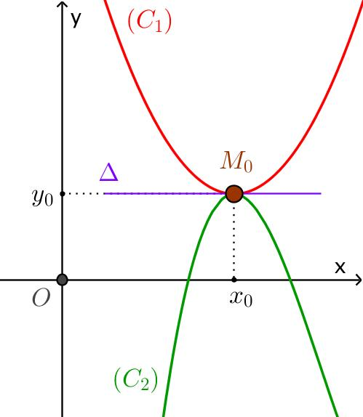
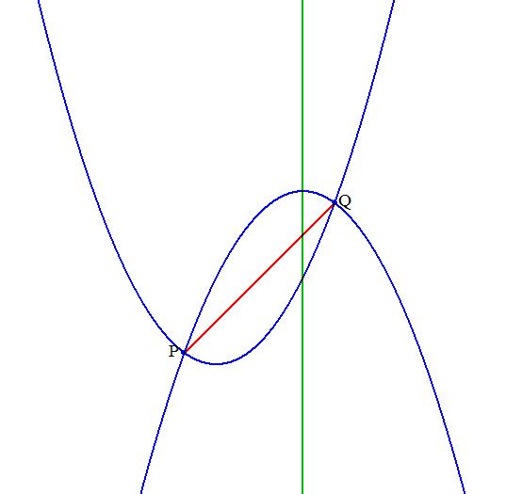
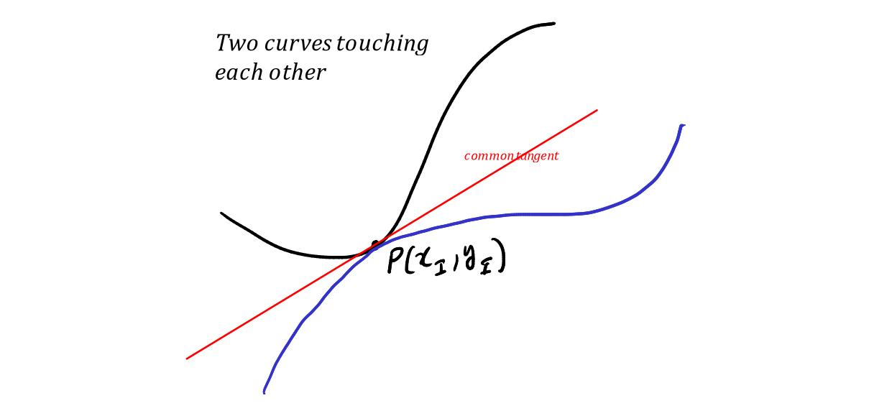
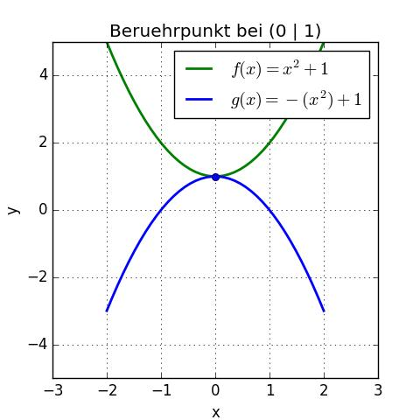
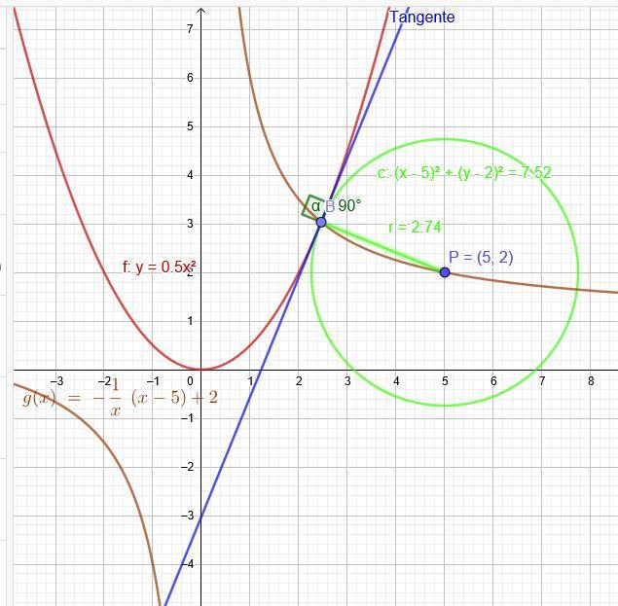

Fundamental Concept
# Source: AI Source: Provided by: [Data Path: Persons Table -> ID Column: 1, Name_En Column: Motasem Essam] -> From: [ChatGPT] on [7/25/2026]
Suppose two curves $C_{1}$and $C_{2}$meet at point $T$.
If they are tangent at $T$, then:
$$\boxed{T∈C_{1}∩C_{2}}$$
and they have the same tangent line at $T$.
Therefore:
$$\boxed{\text{Tangent to }C_{1}=\text{Tangent to }C_{2}}$$
at $T$.
The curves may lie on the same side of the tangent line near $T$, rather than crossing through one another.

Main Parts
# Source: AI Source: Provided by: [Data Path: Persons Table -> ID Column: 1, Name_En Column: Motasem Essam] -> From: [ChatGPT] on [7/25/2026]
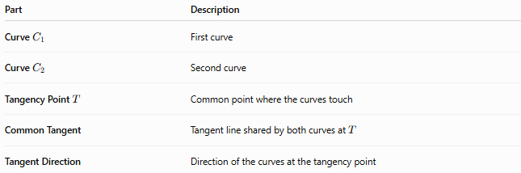
Part | Description
Curve $C_{1}$ | First curve
Curve $C_{2}$ | Second curve
Tangency Point $T$ | Common point where the curves touch
Common Tangent | Tangent line shared by both curves at $T$
Tangent Direction | Direction of the curves at the tangency point

Tangency Point
# Source: AI Source: Provided by: [Data Path: Persons Table -> ID Column: 1, Name_En Column: Motasem Essam] -> From: [ChatGPT] on [7/25/2026]
The Tangency Point is the point shared by the two curves where their tangent directions agree.
For curves $C_{1}$and $C_{2}$:
$$\boxed{T∈C_{1}∩C_{2}}$$
and:
$$\boxed{\text{same tangent direction at }T}$$
The tangency point does not necessarily have to be a point on a circle. It can occur between many different types of curves.

Common Tangent
# Source: AI Source: Provided by: [Data Path: Persons Table -> ID Column: 1, Name_En Column: Motasem Essam] -> From: [ChatGPT] on [7/25/2026]
At a regular curve–curve tangency, both curves have the same tangent line.
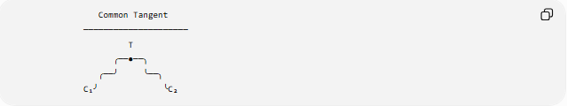
Common Tangent
─────────────────────
T
╭──●──╮
╭──╯ ╰──╮
C₁╯ ╰C₂
Thus, if the common tangent has equation:
$$y=mx+b$$
then both curves have tangent slope:
$$\boxed{m}$$
at $T$.

Tangency of Two Functions
# Source: AI Source: Provided by: [Data Path: Persons Table -> ID Column: 1, Name_En Column: Motasem Essam] -> From: [ChatGPT] on [7/25/2026]
Suppose two functions are:
$$y=f\left(x\right)$$
and:
$$y=g\left(x\right)$$
They are tangent at:
$$T=\left(x_{0} , y_{0}\right)$$
when, under the usual differentiability conditions:
Same point
$$\boxed{f\left(x_{0}\right)=g\left(x_{0}\right)}$$
Same slope
$$\boxed{f^{'}\left(x_{0}\right)=g^{'}\left(x_{0}\right)}$$
Therefore, the two curves meet at the same point and have the same tangent direction there.

Example — Two Parabolas
# Source: AI Source: Provided by: [Data Path: Persons Table -> ID Column: 1, Name_En Column: Motasem Essam] -> From: [ChatGPT] on [7/25/2026]
Consider:
$$f\left(x\right)=x^{2}$$
and:
$$g\left(x\right)=2x^{2}$$
At $x=0$:
$$f\left(0\right)=g\left(0\right)=0$$
so both pass through:
$$T=\left(0 , 0\right)$$
Their derivatives are:
$$f^{'}\left(x\right)=2x$$
and:
$$g^{'}\left(x\right)=4x$$
Therefore:
$$f^{'}\left(0\right)=g^{'}\left(0\right)=0$$
Both curves have the same tangent line at $T$:
$$\boxed{y=0}$$
Thus they are tangent at the origin.

Circle–Curve Tangency
# Source: AI Source: Provided by: [Data Path: Persons Table -> ID Column: 1, Name_En Column: Motasem Essam] -> From: [ChatGPT] on [7/25/2026]
A circle can be tangent to another curve.
Examples include:
- circle–parabola;
- circle–ellipse;
- circle–hyperbola;
- circle–other smooth curve.
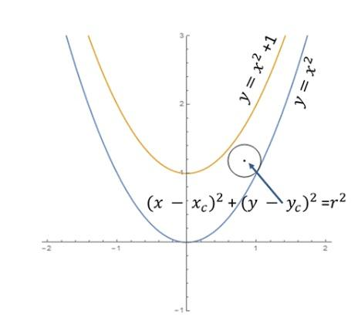
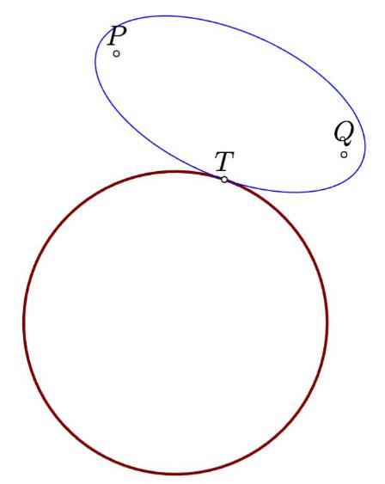
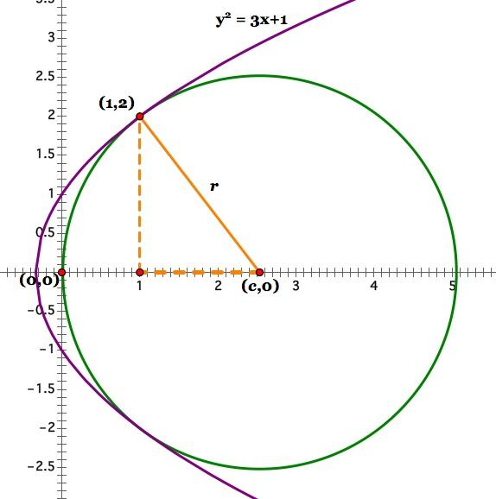
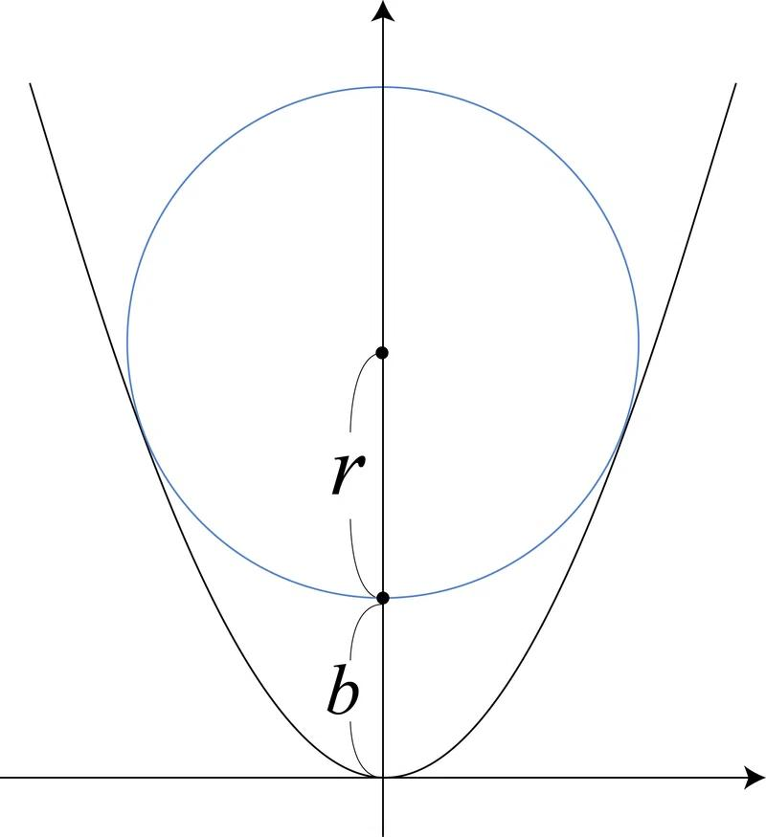
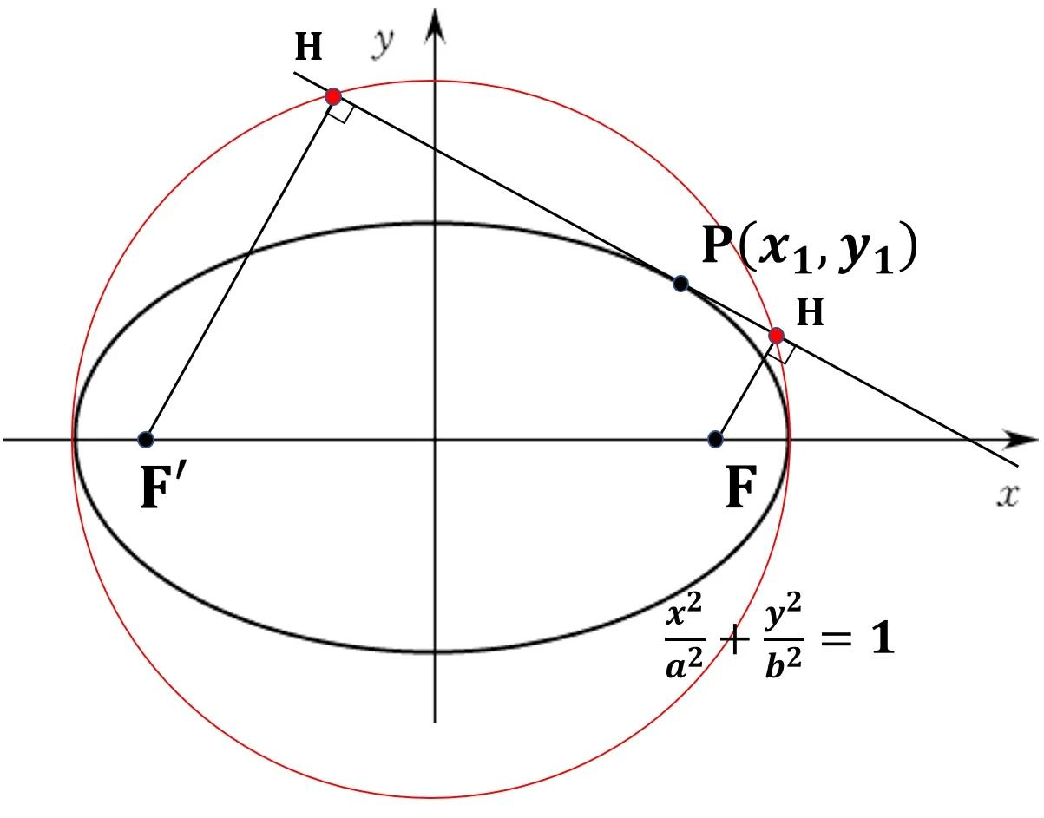
At the tangency point, the circle and the other curve share the same tangent line.
For a circle, the radius to the tangency point is perpendicular to that common tangent.

Two Circles as a Special Case
# Source: AI Source: Provided by: [Data Path: Persons Table -> ID Column: 1, Name_En Column: Motasem Essam] -> From: [ChatGPT] on [7/25/2026]
Circle–Circle Tangency is a special case of curve–curve tangency.
For two tangent circles:
$$O_{1}, T, O_{2}$$
are collinear, and their common tangent at $T$is perpendicular to the line joining the centers.
Thus:
$$\boxed{O_{1}O_{2}⊥\text{common tangent}}$$
This includes:
- external circle–circle tangency;
- internal circle–circle tangency.

Curve–Curve Tangency vs. Curve Intersection
# Source: AI Source: Provided by: [Data Path: Persons Table -> ID Column: 1, Name_En Column: Motasem Essam] -> From: [ChatGPT] on [7/25/2026]
Two curves may meet without being tangent.
Ordinary intersection
The curves cross at the intersection point.
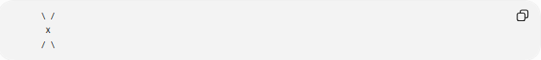
\ /
X
/ \
Tangency
The curves touch and have the same tangent direction.
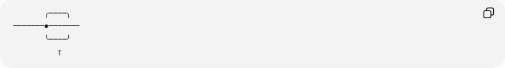
╭────╮
───────●───────
╰────╯
T
The important distinction is the tangent direction:
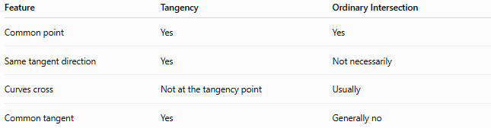
Feature | Tangency | Ordinary Intersection
Common point | Yes | Yes
Same tangent direction | Yes | Not necessarily
Curves cross | Not at the tangency point | Usually
Common tangent | Yes | Generally no

Tangency and Derivatives
# Source: AI Source: Provided by: [Data Path: Persons Table -> ID Column: 1, Name_En Column: Motasem Essam] -> From: [ChatGPT] on [7/25/2026]
For differentiable functions:
$$y=f\left(x\right)$$
and:
$$y=g\left(x\right)$$
tangency at $x=x_{0}$requires:
$$\boxed{f\left(x_{0}\right)=g\left(x_{0}\right)}$$
and:
$$\boxed{f^{'}\left(x_{0}\right)=g^{'}\left(x_{0}\right)}$$
The first condition ensures that the curves meet.
The second ensures that they have the same instantaneous direction.

Common Tangent Equation
# Source: AI Source: Provided by: [Data Path: Persons Table -> ID Column: 1, Name_En Column: Motasem Essam] -> From: [ChatGPT] on [7/25/2026]
If two curves are tangent at:
$$T=\left(x_{0} , y_{0}\right)$$
and their common slope is:
$$m$$
then their common tangent line is:
$$\boxed{y-y_{0}=m\left(x-x_{0}\right)}$$
where:
$$m=f^{'}\left(x_{0}\right)=g^{'}\left(x_{0}\right)$$

Parametric Curves
# Source: AI Source: Provided by: [Data Path: Persons Table -> ID Column: 1, Name_En Column: Motasem Essam] -> From: [ChatGPT] on [7/25/2026]
Curve–curve tangency can also occur when curves are represented parametrically.
For a curve:
$$r\left(t\right)=\left(x , \left(t\right)y\left(t\right)\right)$$
the tangent direction is determined by:
$$r^{'}\left(t\right)$$
Two parametric curves are tangent at a common point when their tangent vectors are parallel.
If:
$$r_{1}^{'}\left(t_{1}\right)=λr_{2}^{'}\left(t_{2}\right)$$
for some nonzero scalar $λ$, then the tangent directions are the same.

Types of Curve–Curve Tangency
# Source: AI Source: Provided by: [Data Path: Persons Table -> ID Column: 1, Name_En Column: Motasem Essam] -> From: [ChatGPT] on [7/25/2026]
A useful classification is:
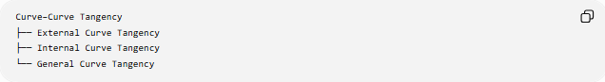
Curve–Curve Tangency
├── External Curve Tangency
├── Internal Curve Tangency
└── General Curve Tangency
External Tangency
The curves approach each other from different regions and touch at one point without one enclosing the other.
Internal Tangency
One closed curve can lie inside another and touch it at one point.
This terminology is especially common for circles, while for arbitrary curves the more general term curve–curve tangency is often preferable.
General Curve Tangency
Two arbitrary curves share a tangent direction at their common point.

Tangency of Different Curve Types
# Source: AI Source: Provided by: [Data Path: Persons Table -> ID Column: 1, Name_En Column: Motasem Essam] -> From: [ChatGPT] on [7/25/2026]
Curve–curve tangency can occur between many combinations:
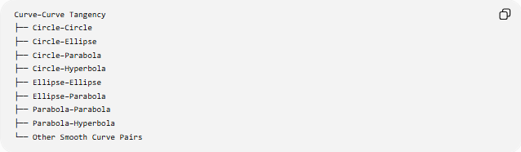
Curve–Curve Tangency
├── Circle–Circle
├── Circle–Ellipse
├── Circle–Parabola
├── Circle–Hyperbola
├── Ellipse–Ellipse
├── Ellipse–Parabola
├── Parabola–Parabola
├── Parabola–Hyperbola
└── Other Smooth Curve Pairs
The essential condition is not the specific curve type but the existence of a common tangent direction at the contact point.

Higher-Order Tangency
# Source: AI Source: Provided by: [Data Path: Persons Table -> ID Column: 1, Name_En Column: Motasem Essam] -> From: [ChatGPT] on [7/25/2026]
Two curves can have the same position and tangent direction but behave differently beyond that.
For example, if:
$$f\left(x_{0}\right)=g\left(x_{0}\right)$$
and:
$$f^{'}\left(x_{0}\right)=g^{'}\left(x_{0}\right)$$
they have ordinary first-order tangency.
If additional derivatives also agree:
$$f^{''}\left(x_{0}\right)=g^{''}\left(x_{0}\right)$$
then the curves have even higher-order contact.
More generally:
$$f^{\left(k\right)}\left(x_{0}\right)=g^{\left(k\right)}\left(x_{0}\right)$$
for several successive derivatives indicates increasingly high-order contact.
This is an advanced form of curve tangency.

Tangency Point and Curvature
# Source: AI Source: Provided by: [Data Path: Persons Table -> ID Column: 1, Name_En Column: Motasem Essam] -> From: [ChatGPT] on [7/25/2026]
At a tangency point, two curves have the same tangent direction, but they do not necessarily have the same curvature.
Therefore:
$$\boxed{\text{Same tangent direction}⇏\text{same curvature}}$$
For example, a circle and a parabola can touch at a point while bending at different rates.
If they also have the same curvature at the contact point, the contact is sometimes described as second-order contact or osculation, depending on the context.

Example — Circle and Line as a Special Case
# Source: AI Source: Provided by: [Data Path: Persons Table -> ID Column: 1, Name_En Column: Motasem Essam] -> From: [ChatGPT] on [7/25/2026]
Although a line is not usually called a curve in elementary geometry, line–circle tangency illustrates the same principle.
A line touches a circle at $T$.
The circle and line share the same tangent direction at $T$, and the radius is perpendicular to the tangent:
$$\boxed{OT⊥l}$$
Thus, line–circle tangency can be understood as a basic example of contact between geometric curves/objects.

Important Properties
# Source: AI Source: Provided by: [Data Path: Persons Table -> ID Column: 1, Name_En Column: Motasem Essam] -> From: [ChatGPT] on [7/25/2026]
- Two tangent curves have a common point called the tangency point.
- At a regular tangency point, the curves have the same tangent direction.
- Two differentiable functions tangent at $x_{0}$satisfy:
$$f\left(x_{0}\right)=g\left(x_{0}\right)$$
and:
$$f^{'}\left(x_{0}\right)=g^{'}\left(x_{0}\right)$$
- The curves do not cross through one another at the tangency point in ordinary tangency.
- A common tangent line can be drawn at the tangency point.
- Circle–circle tangency is a special case of curve–curve tangency.
- Two tangent curves can have different curvatures.
- Higher-order contact occurs when additional derivatives agree.
- The tangency point is a geometric point, while the common tangent is the line describing the curves' local direction.

Classification Tree
# Source: AI Source: Provided by: [Data Path: Persons Table -> ID Column: 1, Name_En Column: Motasem Essam] -> From: [ChatGPT] on [7/25/2026]
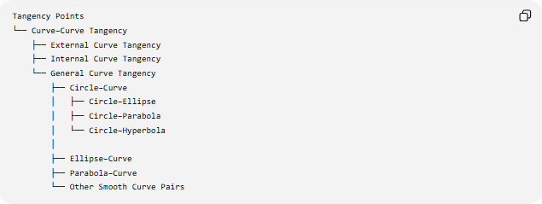
Tangency Points
└── Curve–Curve Tangency
├── External Curve Tangency
├── Internal Curve Tangency
└── General Curve Tangency
├── Circle–Curve
│ ├── Circle–Ellipse
│ ├── Circle–Parabola
│ └── Circle–Hyperbola
│
├── Ellipse–Curve
├── Parabola–Curve
└── Other Smooth Curve Pairs

Key Formulas
# Source: AI Source: Provided by: [Data Path: Persons Table -> ID Column: 1, Name_En Column: Motasem Essam] -> From: [ChatGPT] on [7/25/2026]
For:
$$y=f\left(x\right)$$
and:
$$y=g\left(x\right)$$
tangent at $x=x_{0}$:
$$\boxed{f\left(x_{0}\right)=g\left(x_{0}\right)} \\ \boxed{f^{'}\left(x_{0}\right)=g^{'}\left(x_{0}\right)}$$
Common tangent:
$$\boxed{y-y_{0}=m\left(x-x_{0}\right)}$$
where:
$$\boxed{m=f^{'}\left(x_{0}\right)=g^{'}\left(x_{0}\right)}$$

Key Points
# Source: AI Source: Provided by: [Data Path: Persons Table -> ID Column: 1, Name_En Column: Motasem Essam] -> From: [ChatGPT] on [7/25/2026]
- Curve–Curve Tangency occurs when two curves touch at a common point and have the same tangent direction there.
- The common point is the Tangency Point.
- The curves share a common tangent line at that point.
- For differentiable functions, equal function values and equal first derivatives characterize ordinary tangency.
- Circle–circle tangency is a specialized form of curve–curve tangency.
- Tangent curves do not necessarily have the same curvature.
- Higher-order tangency occurs when additional derivatives also agree.

Conclusion
# Source: AI Source: Provided by: [Data Path: Persons Table -> ID Column: 1, Name_En Column: Motasem Essam] -> From: [ChatGPT] on [7/25/2026]
Curve–Curve Tangency is the general geometric concept of two curves making contact at a point with the same local direction. The tangency point and common tangent are its two fundamental elements. It generalizes familiar cases such as circle–circle tangency and line–circle tangency to arbitrary smooth curves.
Would you like a worked example finding the tangency point of two functions, or a geometric example involving two circles?

